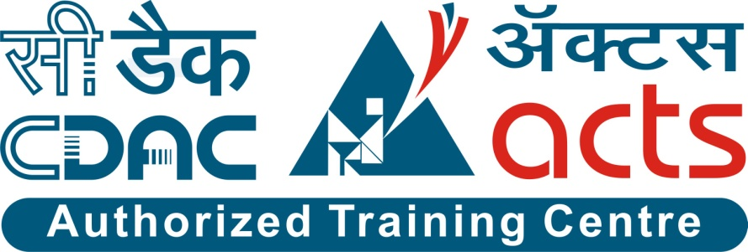

Project Name: Art For Welfare

Branch PG-DAC March-2023

Documentation On

**“Art For Welfare”**

PG-DAC March-2023

**Guided By: Snehal Somvanshi**

Submitted By :

**Group No: 12**

* **Abhinav Kumar 200943020001**
* **Mahendra Kumar Meena 200943020054**
* **Nikhil Talmale 200943020063**
* **Tushar Dhanorkar 200943020026**

**Table of Contents**

**1. Introduction 4**

1.1 Document Purpose **4**

1.2 Project Background **4**

1.3 Aim & Objectives **4**

**2. Business Requirements Overview**…………………………………………………………**5**

**3.Functional Requirements** **6**

3.1 Admin Module **6**

3.2 Artist Module **6**

3.3 Customer Module **6**

3.4 NGO Module **6**

**4.** **Non-Functional Requirement………………………………………………………………7**

**5. Use Case Diagram 8**

5.1 Admin **9**

5.2 Artist **10**

5.3 Customer **11**

5.4 NGO **11**

**6. Database Design 12**

1 Role **12**

2 User Table **12**

3 Question Table ………………………………………………………………………… **13**

4 Customer Table **13**

5 Admin Table **13**

6 Artist Table **13**

7 NGO table **13**

8 Categories Table **13**

9 Area Table **14**

10 City Table **14**

11 State Table **14**

12 Order Table………………………………………………………………………………………**15**

13 Arts Table………………………………………………………………………………….….…**15**

14 Order Details Table…………………………………………………………………………...…**15**

15 NGO Fund Table………………………………………………………………………...………**15**

16 AFW Table……………………………………………………………………… ……………...**15**

17 AFW Fund Table…………………………………………..……………………………………**15**

**7. E-R Diagram………………………………………………………………………………………14**

**8. Snapshots 15**

**9. Conclusion 20**

**List of Figures**

**Use Case Diagrams 17**

Fig 1 Admin 8

Fig 2 Artist 9

Fig 3 Customers 10

Fig 4 ER Diagram 14

1. **Introduction:**
   1. **Document Purpose:**

The purpose of this document is to define the business requirements and scope for the Art for Welfare initiative. This project aims to promote art and also promoting social welfare and community development. The scope of this document encompasses the functional and non-functional requirements, business rules, and other constraint requirements for the Art for Welfare platform.

## Project Background:

Within the realm of art, there are numerous non-professional artists, including street artists and individuals who create art purely for enjoyment and personal expression. However, the existing system often overlooks the valuable contributions and potential of these artists to contribute to social welfare initiatives. Their artwork remains untapped as a means of generating funds and support for various welfare projects.

Art For Welfare is a unique platform which brings Artist, NGO and Customers together,

Where Artist can showcase their art, Customer can see and buy the arts uploaded by Artist .

The Amount Received by selling Art is directly funded to NGOs. NGO are benefitted

Directly.

## Aim & Objectives:

The goal of the Art for welfare project is to establish a platform that enables

professional and non-professional artists to contribute their artwork for social

welfare initiative, while raising funds to support various welfare projects.

Through the Art For Welfare project , professional and non-professional artists , including street artists and those who create art for personal enjoyment , will have the opportunity to post their artwork. These posted artworks will be made available for sale , with the proceeds directed towards funding welfare initiative such as education , healthcare , poverty alleviation , environmental conservation , and other deserving causes.

1. **Business Requirements Overview:**

* Art for Welfare platform is the public web application.
* Art for Welfare platform will be open globally, but in the phase 1, the main target is India.
* There are mainly three types of users - Artist , Customer and NGO.
* Customers can search for the Artworks.
* Artist can select the NGO from the list and can post art for specific NGO.
* Art For Welfare platform provides the facility to connect the Artists , NGO and Customers.
* Art For Welfare platform could be maintained by the Administrator.
* Platform will take operations charges in the form of some percentage share from every transaction as well as take donations which will act as revenue to maintain operations of platform.

# Functional Requirements Overview:

Our Portal consists of four modules described as below.

1. Artist’s Module
2. Customer’s Module
3. Admin Module
4. NGO ‘s Module

# 3.1 Artist Module

* Artist can register and create his own account.
* Artist can login with proper credentials.
* Artist should have his own profile page.
* Artist can see the listed NGO’s
* Artist will be able to publish his Arts for listed NGO’s.

# Customer Module

* Customer can register and create his own account.
* Customer will be able to login with proper credentials.
* Customer will have profile page.
* Customer will be able to see all artworks.
* Customer will be able to search arts according to categories of arts.

# Admin Module

* Admin will be able to login with proper credentials.
* Admin will verify NGO’s using documents provided by them.
* Admin will be able to remove any NGO, customer or artist.

# 3.4 NGO Module

* NGO must submit appropriate documents for verification.
* NGO will be able to Login with proper credentials.
* NGO Can receive the fund.

1. **Non-Functional Requirement:**

* The website should use professional design, look and feel and color scheme.
* Users will have no limitations for accessing the application through Internet. The portal being an internet application, it is difficult to specify exact number of visitor or users. Hence we will target the system to support multiple users .
* Being a public website, the site must follow general usability guidelines for menus, navigation, colors, links and other actions provided on the screens.
* The system should be designed in such a manner that user will be able to complete tasks in minimum number of steps.
* Any personal or sensitive information collected as part of the program should be handled securely.

.

## 5. Use-Case Diagram

**5.1 Admin:**

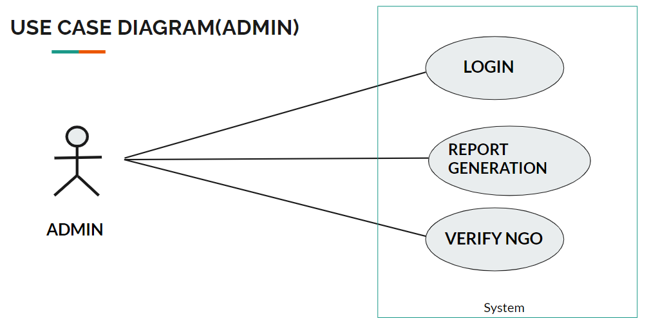

Fig. Use-Case Diagram for Admin

## 5.2Artist:

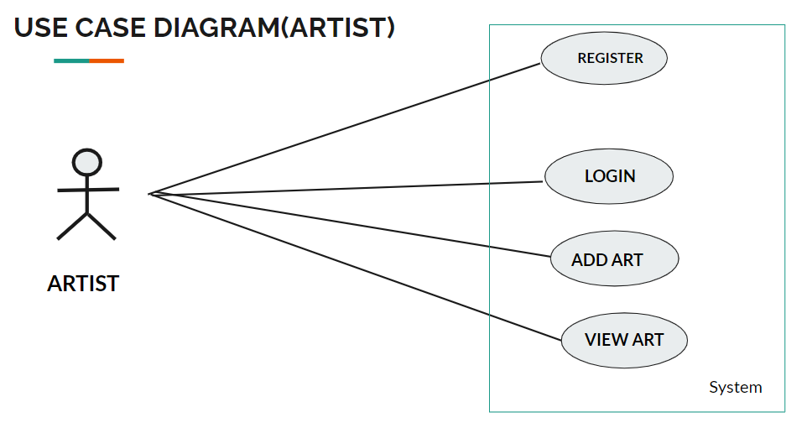

Fig. Use-Case Diagram for Artist

**5.3 Customers**

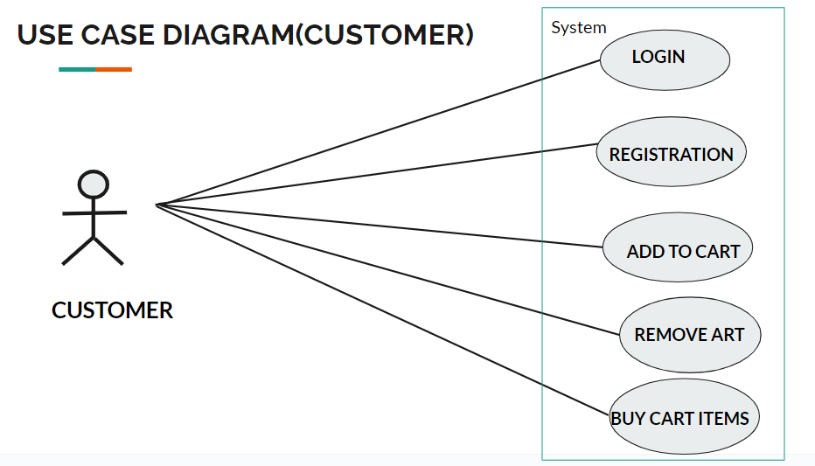

Fig. Use-Case Diagram for Customer

**5.4 NGO**

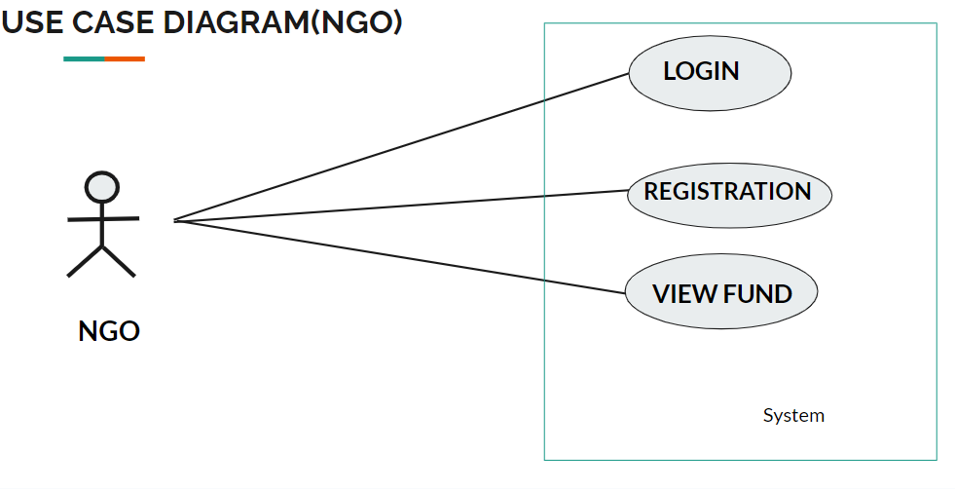

Fig. Use-Case Diagram for NGO

**6. Database Design:**

1. **Role Table**



|  |  |  |  |  |  |
| --- | --- | --- | --- | --- | --- |
| **Field** | **Type** | **Null** | **Key** | **Auto Increment** | **Description** |
| role_id | INT | NO | PRIMARY KEY | YES |  |
| role_name | VARCHAR(20) | NO | FOREIGN KEY | NO |  |
|  |  |  |  |  |  |

1. **Questions Table**

|  |  |  |  |  |  |
| --- | --- | --- | --- | --- | --- |
| **Field** | **Type** | **Null** | **Key** | **Auto Increment** | **Description** |
| que_id | INT | NO | PRIMARY KEY | YES |  |
| que_text | TEXT | NO |  | NO |  |
|  |  |  |  |  |  |

1. **Users Table**

|  |  |  |  |  |  |
| --- | --- | --- | --- | --- | --- |
| **Field** | **Type** | **Null** | **Key** | **Auto Increment** | **Description** |
| user_id | INT | NO | PRIMARY KEY | YES |  |
| user_name | VARCHAR(20) | NO |  | NO |  |
| password | VARCHAR(20) | NO |  | NO |  |
| email | VARCHAR(20) | NO |  | NO |  |
| role_id | INT | NO | FOREIGN KEY | NO |  |
| que_id | INT | NO | FOREIGN KEY | NO |  |
| answer | TEXT | NO |  | NO |  |
| approve | TINYINT(1) | NO |  | NO |  |
|  |  |  |  |  |  |

1. **Customers Table**

|  |  |  |  |  |  |
| --- | --- | --- | --- | --- | --- |
| **Field** | **Type** | **Null** | **Key** | **Auto Increment** | **Description** |
| cust_id | INT | NO | PRIMARY KEY | YES |  |
| user_id | INT | NO | FOREIGN KEY | NO |  |
| fname | VARCHAR(50) | NO |  | NO |  |
| lname | VARCHAR(50) | NO |  | NO |  |
| area_id | INT | NO | FOREIGN KEY | NO |  |

1. **Admin Table**

|  |  |  |  |  |  |
| --- | --- | --- | --- | --- | --- |
| **Field** | **Type** | **Null** | **Key** | **Auto Increment** | **Description** |
| admin_id | INT | NO | PRIMARY KEY | YES |  |
| User_id | INT | NO | FOREIGN KEY | NO |  |
| fname | VARCHAR(50) | NO |  | NO |  |
| lname | VARCHAR(50) | NO |  | NO |  |

1. **Artists Table**

|  |  |  |  |  |  |
| --- | --- | --- | --- | --- | --- |
| **Field** | **Type** | **Null** | **Key** | **Auto Increment** | **Description** |
| artist_id | INT | NO | PRIMARY KEY | YES |  |
| user_id | INT | NO | FOREIGN KEY | NO |  |
| fname | VARCHAR(50) | NO |  | NO |  |
| lname | VARCHAR(50) | NO |  | NO |  |
| area_id | INT | NO | FOREIGN KEY | NO |  |
| address | VARCHAR(255) | YES |  | NO |  |
| contact | VARCHAR(20) | NO | UNIQUE KEY | NO |  |
| speciality | VARCHAR(100) | YES |  | NO |  |

1. **NGO table**

|  |  |  |  |  |  |
| --- | --- | --- | --- | --- | --- |
| **Field** | **Type** | **Null** | **Key** | **Auto Increment** | **Description** |
| ngo_id | INT | NO | PRIMARY KEY | YES |  |
| user_id | INT | NO | FOREIGN KEY | NO |  |
| fname | VARCHAR(50) | NO |  | NO |  |
| lname | VARCHAR(50) | YES |  | NO |  |
| area_id | INT | NO | FOREIGN KEY | NO |  |
| address | VARCHAR(255) | NO |  | NO |  |
| contact | VARCHAR(20) | NO | UNIQUE KEY | NO |  |
| certificate | BLOB | YES |  | NO |  |
| account_no | VARCHAR(20) | YES | UNIQUE KEY | NO |  |
|  |  |  |  |  |  |

1. **Categories Table**

|  |  |  |  |  |  |
| --- | --- | --- | --- | --- | --- |
| **Field** | **Type** | **Null** | **Key** | **Auto Increment** | **Description** |
| cat_id | INT | NO | PRIMARY KEY | YES |  |
| cat_name | VARCHAR(50) | NO |  | NO |  |
|  |  |  |  |  |  |

1. **Area Table**

|  |  |  |  |  |  |
| --- | --- | --- | --- | --- | --- |
| **Field** | **Type** | **Null** | **Key** | **Auto Increment** | **Description** |
| area_id | INT | NO | PRIMARY KEY | YES |  |
| area_name | VARCHAR(100) | NO |  | NO |  |
| city_id | INT | NO | FOREIGN | NO |  |

1. **City Table**

|  |  |  |  |  |  |
| --- | --- | --- | --- | --- | --- |
| **Field** | **Type** | **Null** | **Key** | **Auto Increment** | **Description** |
| city_id | INT | NO | PRIMARY KEY | YES |  |
| city_name | VARCHAR(50) | NO |  | NO |  |
| state_id | INT | NO | FOREIGN KEY | NO |  |

1. **State Table**

|  |  |  |  |  |  |
| --- | --- | --- | --- | --- | --- |
| **Field** | **Type** | **Null** | **Key** | **Auto Increment** | **Description** |
| state_id | INT | NO | PRIMARY KEY | YES |  |
| state_name | VARCHAR(50) | NO |  | NO |  |
|  |  |  |  |  |  |

1. **Arts table**

|  |  |  |  |  |  |
| --- | --- | --- | --- | --- | --- |
| **Field** | **Type** | **Null** | **Key** | **Auto Increment** | **Description** |
| art_id | INT | NO | PRIMARY KEY | YES |  |
| artist_id | INT | NO | FOREIGN KEY | NO |  |
| cat_id | INT | NO | FOREIGN KEY | NO |  |
| price | DECIMAL(10,2) | NO |  | NO |  |
| ngo_id | INT | NO | FOREIGN KEY | NO |  |
| description | TEXT | YES |  | NO |  |
| art_name | VARCHAR(50) | NO |  | NO |  |
| status | VARCHAR(10) | NO |  | NO |  |
| image | BLOB | NO |  | NO |  |
|  |  |  |  |  |  |

1. **Orders Table**

|  |  |  |  |  |  |
| --- | --- | --- | --- | --- | --- |
| **Field** | **Type** | **Null** | **Key** | **Auto Increment** | **Description** |
| order_id | INT | NO | PRIMARY KEY | YES |  |
| cust_id | INT | NO |  | NO |  |
| amount | DECIMAL(10,2) | NO | FOREIGN KEY | NO |  |
| date | DATE | NO |  | NO |  |

1. **Order Details Table**

|  |  |  |  |  |  |
| --- | --- | --- | --- | --- | --- |
| **Field** | **Type** | **Null** | **Key** | **Auto Increment** | **Description** |
| od_id | INT | NO | PRIMARY KEY | YES |  |
| order_id | INT | NO | FOREIGN KEY | NO |  |
| art_id | INT | NO | FOREIGN KEY | NO |  |

1. **NGO Fund Table**

|  |  |  |  |  |  |
| --- | --- | --- | --- | --- | --- |
| **Field** | **Type** | **Null** | **Key** | **Auto Increment** | **Description** |
| nf_id | INT | NO | PRIMARY KEY | YES |  |
| ngo_id | INT | NO | FOREIGN KEY | NO |  |
| art_id | INT | NO | FOREIGN KEY | NO |  |
| amount | DECIMAL(10,2) | NO |  | NO |  |
| datetime | DATETIME | NO |  | NO |  |

1. **AFW Fund Table**

|  |  |  |  |  |  |
| --- | --- | --- | --- | --- | --- |
| **Field** | **Type** | **Null** | **Key** | **Auto Increment** | **Description** |
| afwf_id | INT | NO | PRIMARY KEY | YES |  |
| art_id | INT | NO | FOREIGN KEY | NO |  |
| amount | DECIMAL(10,2) | NO |  | NO |  |
| datetime | DATETIME | NO |  | NO |  |

## ER-Diagram:

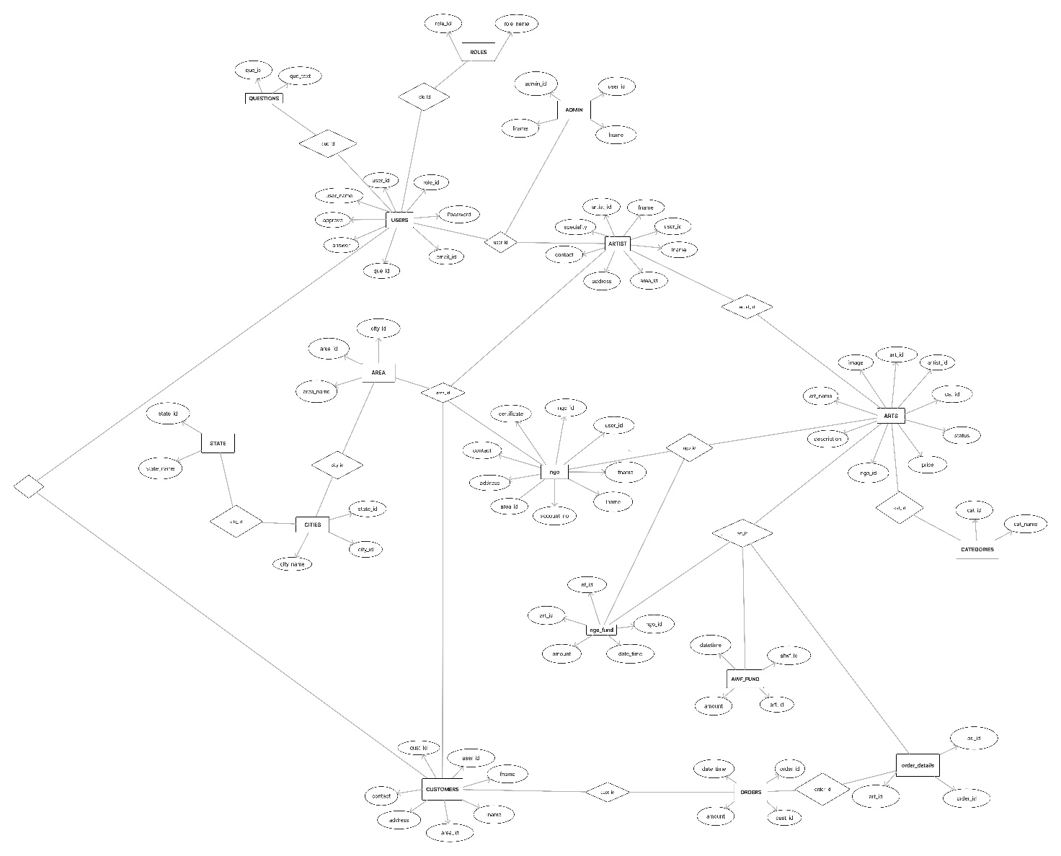

**E-R diagram**

**8. Snapshots:**

**8.1 Home Page:**

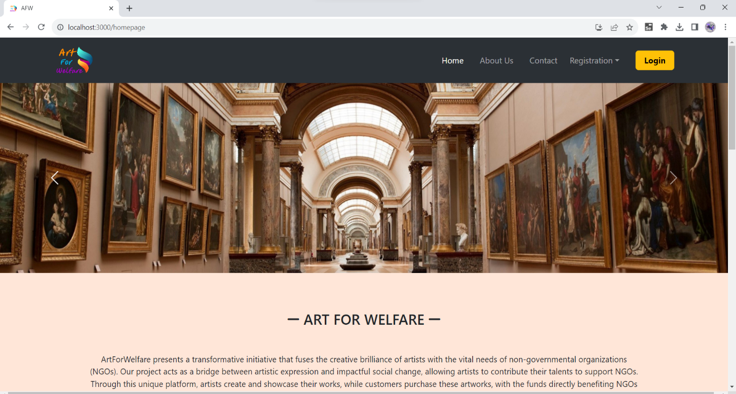

.

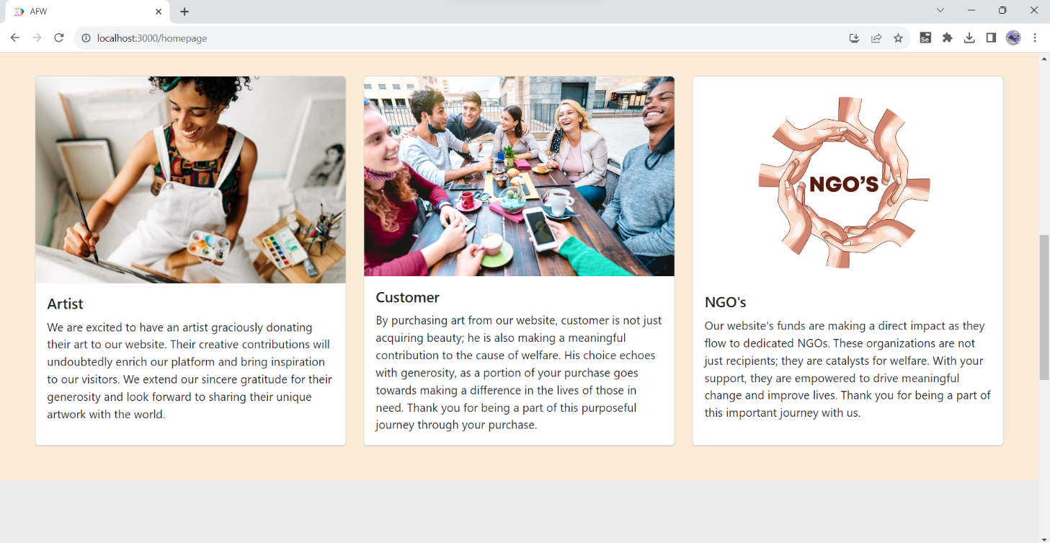

**8.1.1 About us**

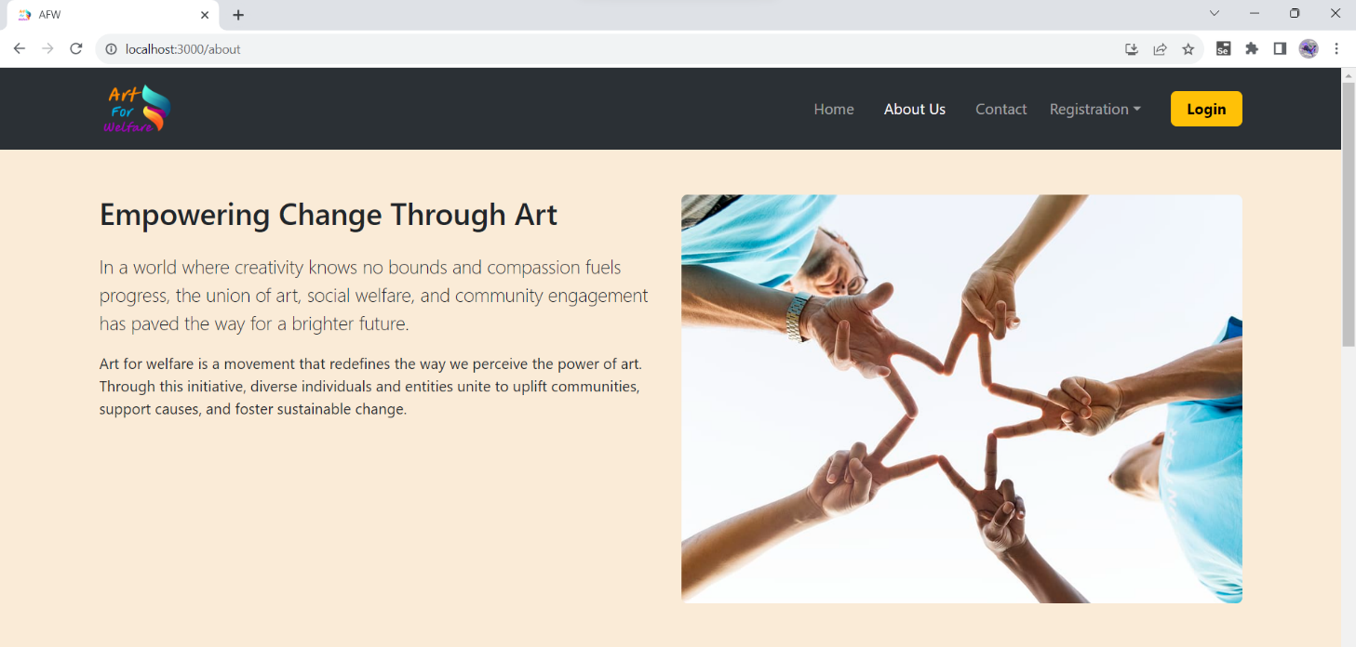

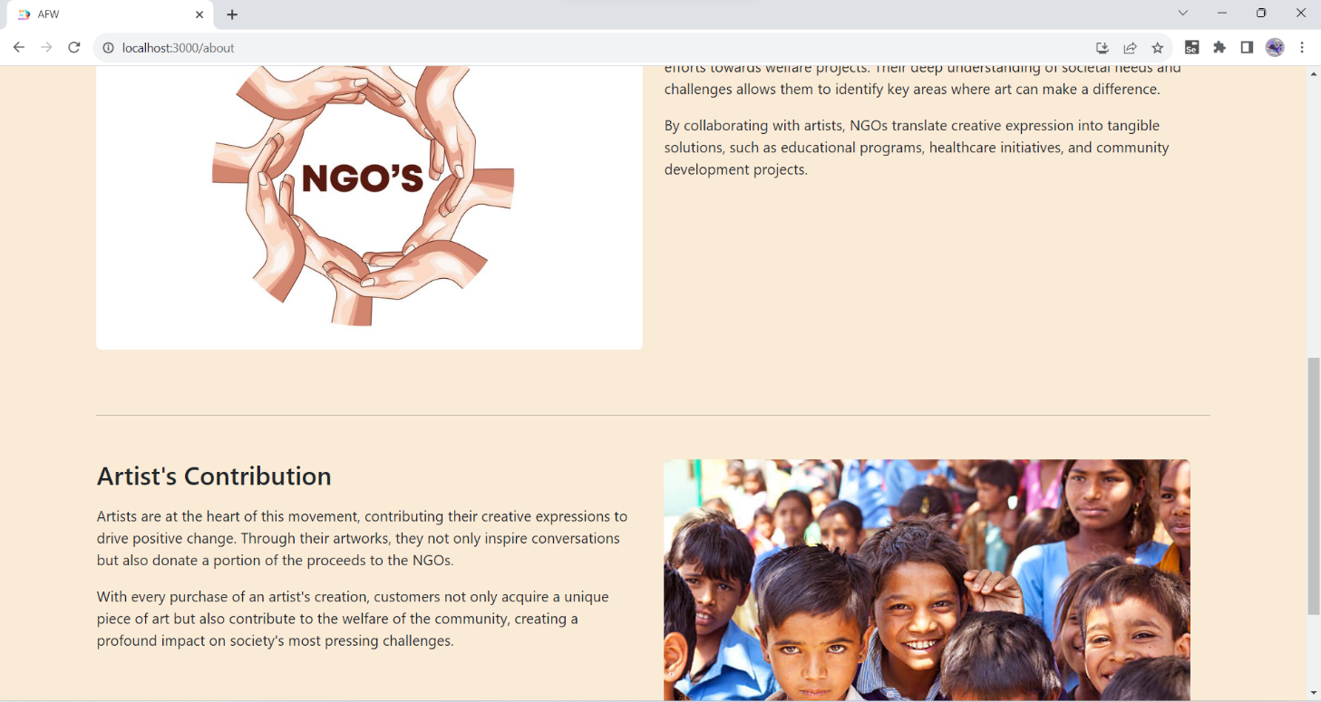

**8.2 Login Page**

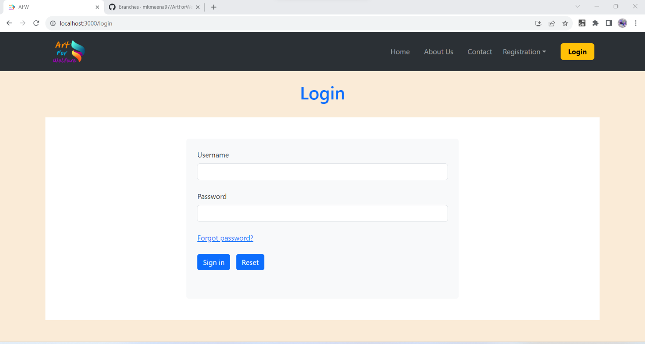

8.2.1 Forgot Password

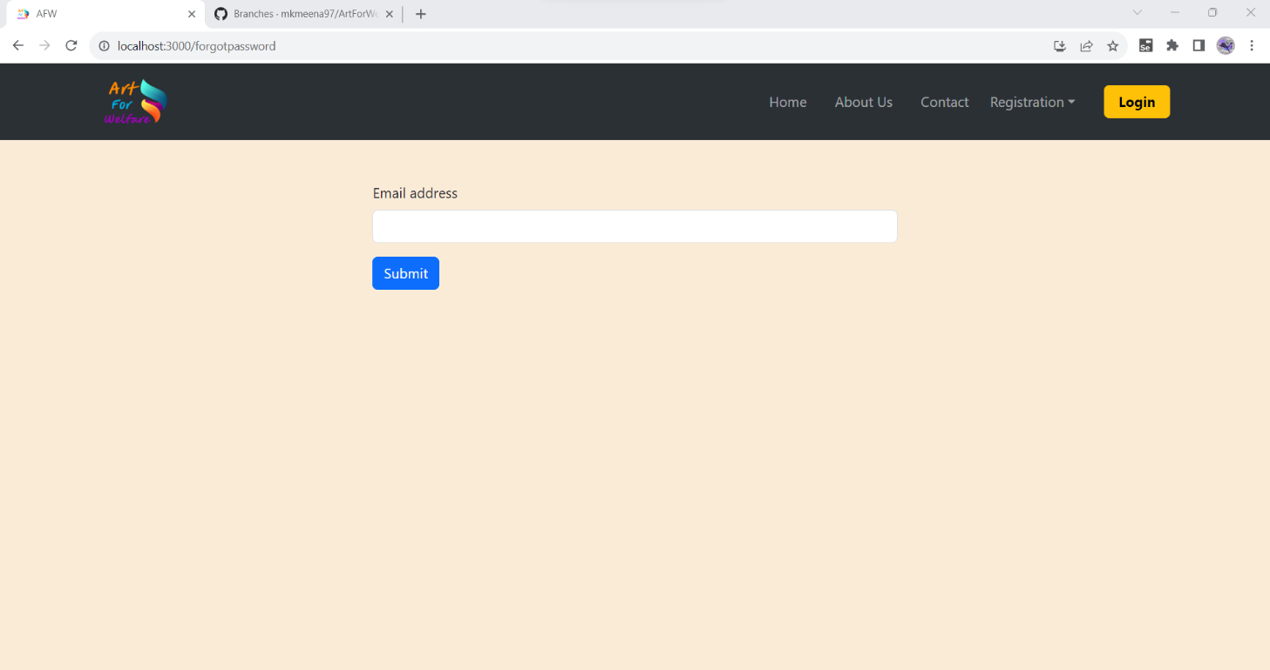

**8.3 Registration Page**

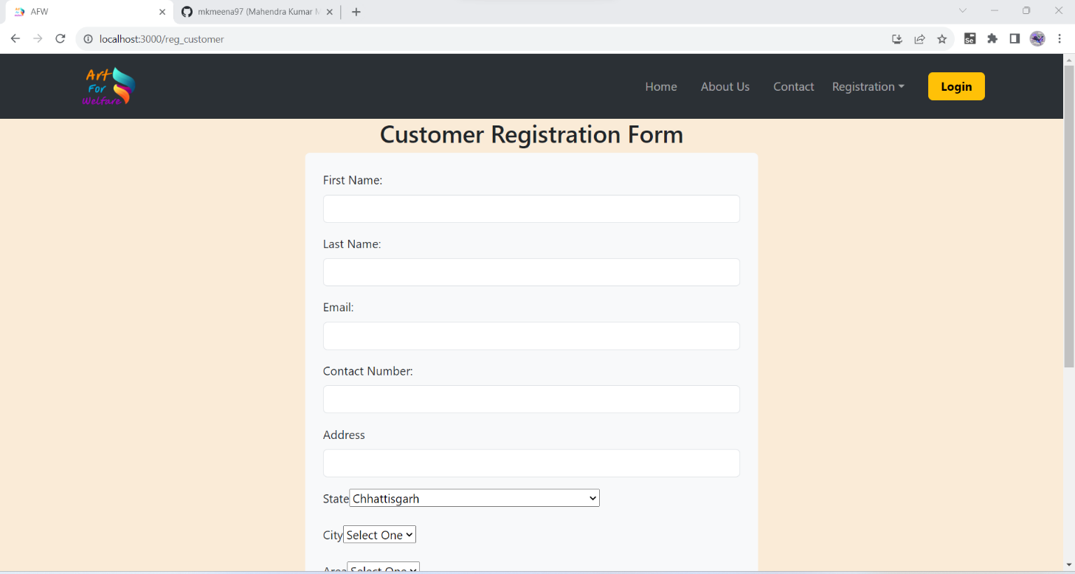

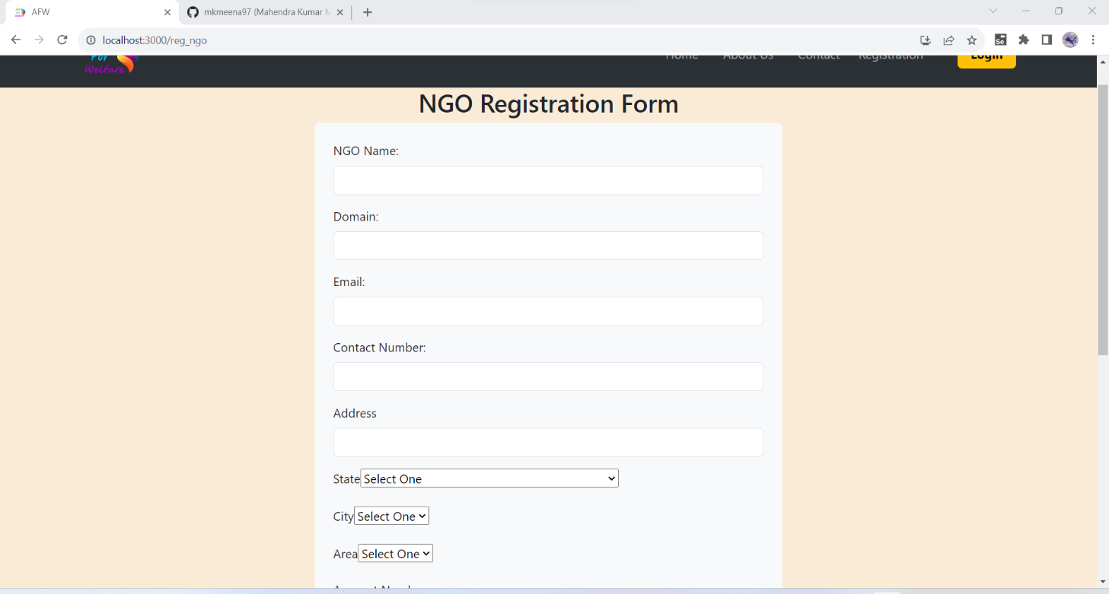

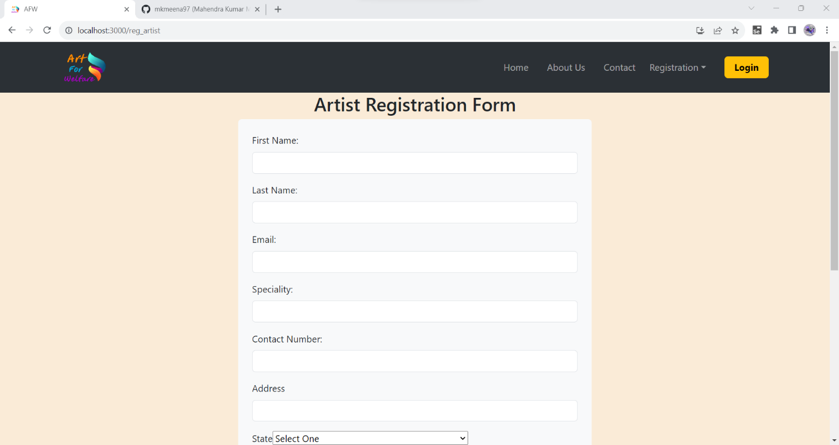

**8.4 Admin Home Page**

**8.4.1 Admin Verify NGO**

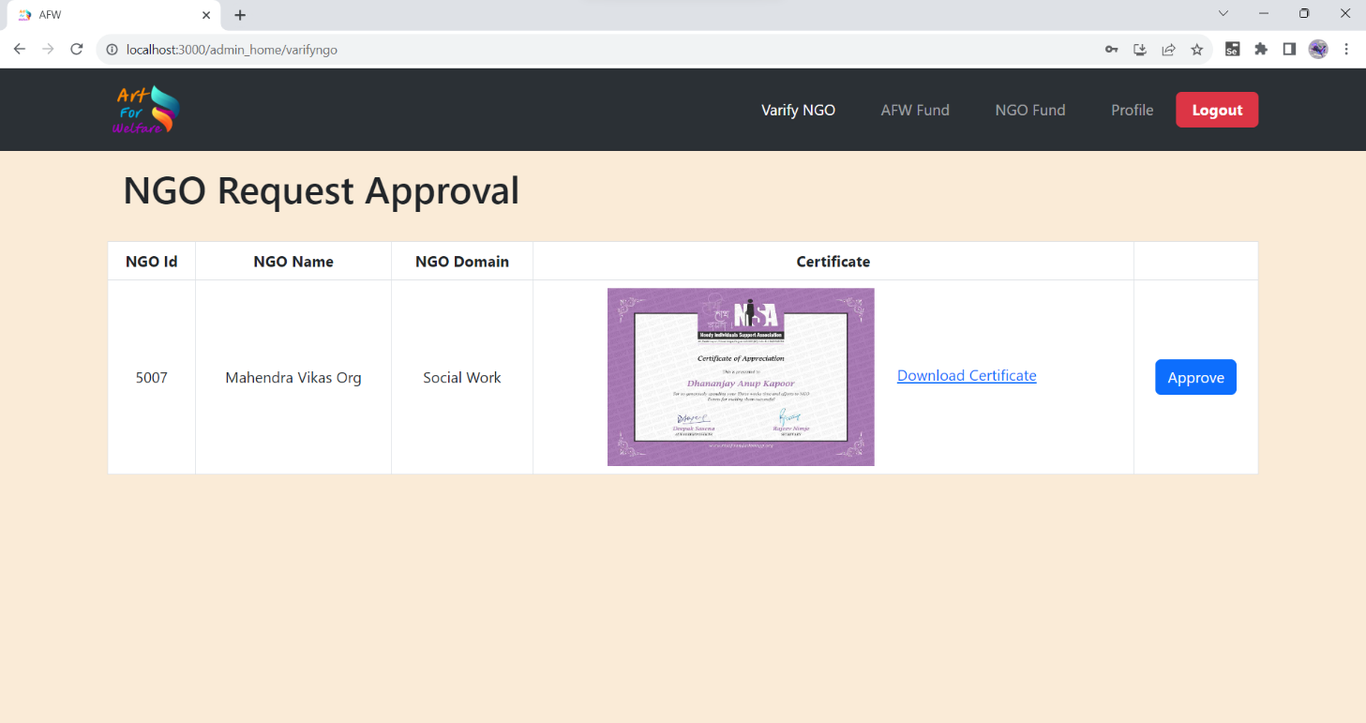

**8.5 Artist Home Page**

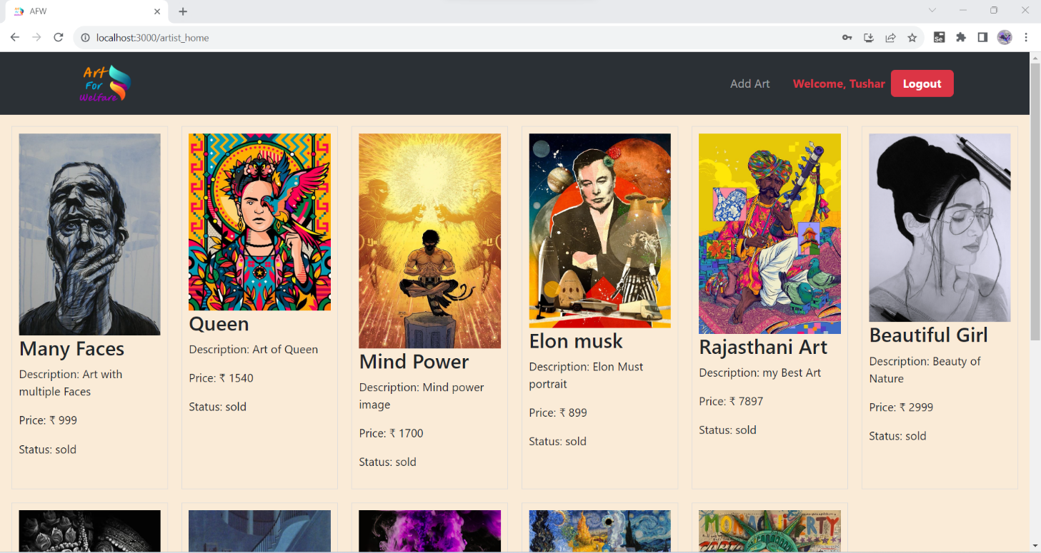

**8.5.2 Add Art**

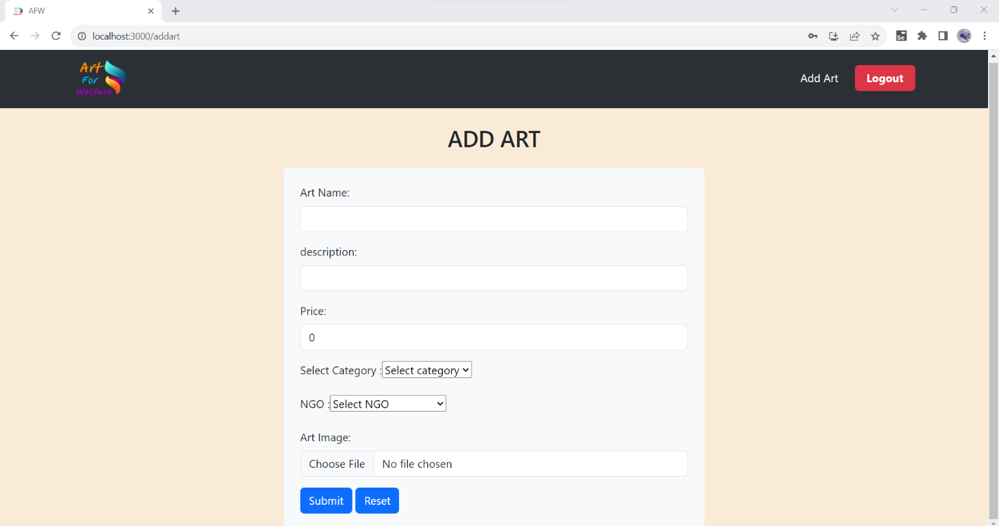

**8.6 Customer Home Page**

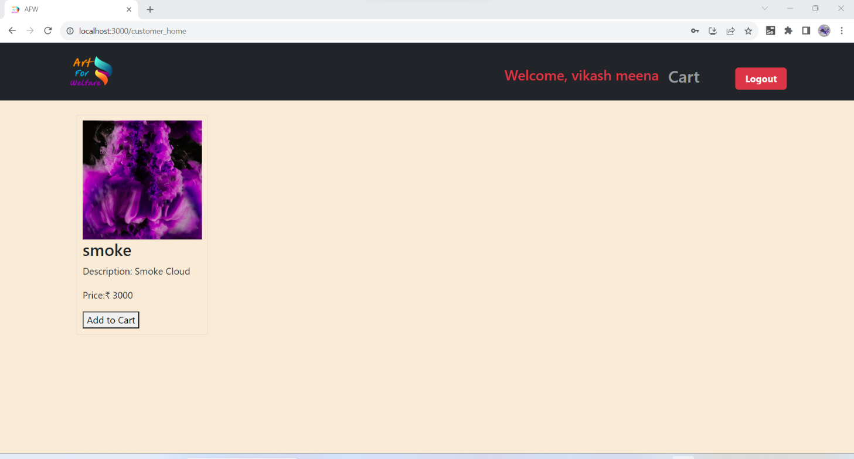

**8.6.1 Cart**

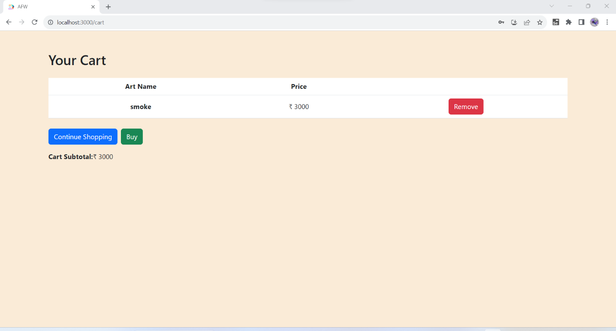

**8.7 NGO Module**

**8.7.1 NGO Home**

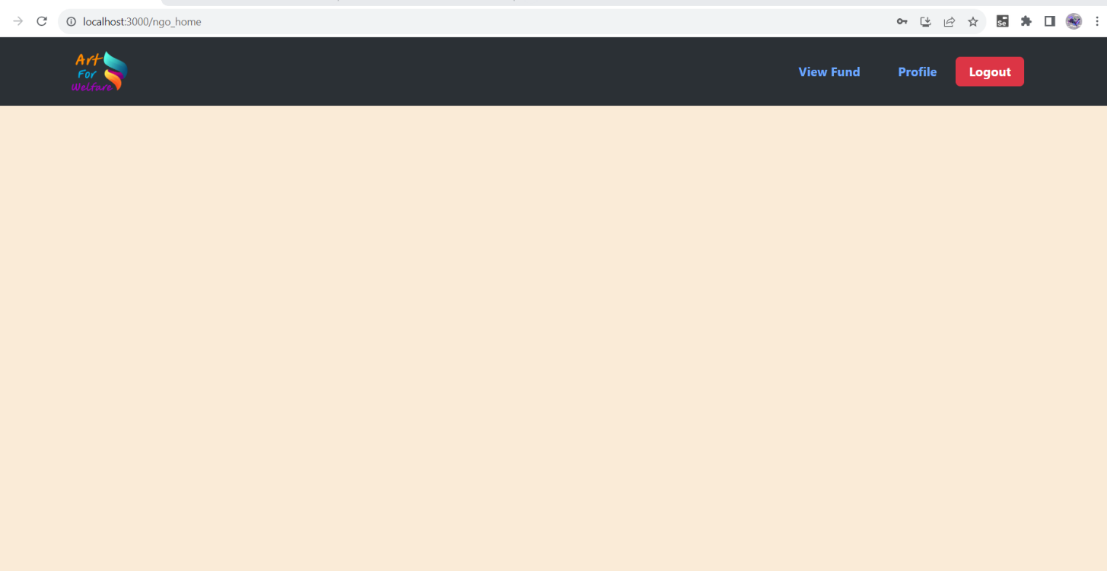

**8.7.2 NGO Profile**

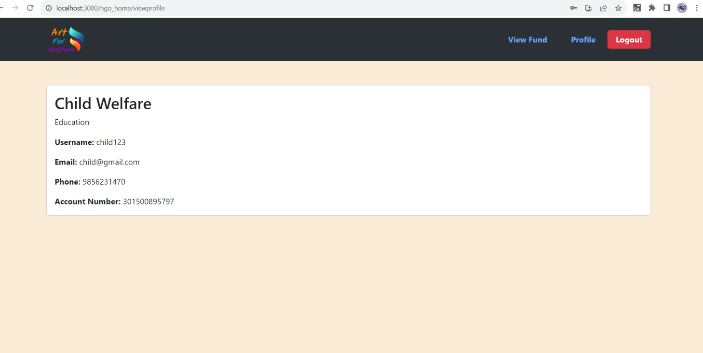

**8.7.3 NGO Fund**

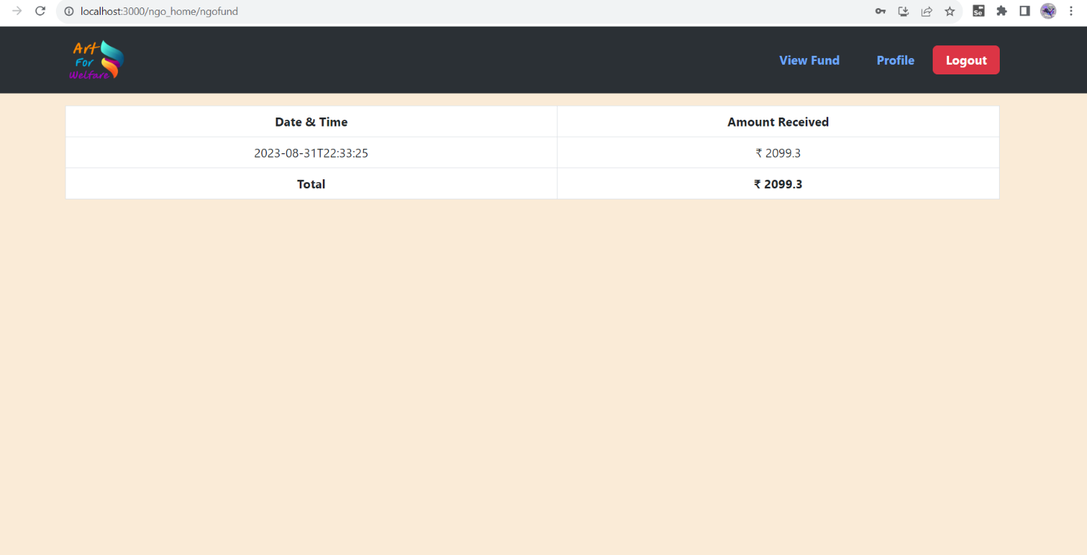

1. **CONCLUSION AND FUTURE SCOPE**

The "Art for Welfare" initiative has been a success, using art to make a positive impact on education, mental health, community development, and culture. The collaboration of artists, volunteers, and supporters has been crucial.

In our project, we cultivated a robust spirit of teamwork marked by open communication, shared goals, mutual support, and respect for diversity, contributing significantly to our success.

Future Scope:

1. Scaling Up: Expand the initiative to help more people.

2. Measuring Impact: Continuously assess the initiative's effects and improve strategies.

3. Sustainability: Secure long-term funding and partnerships.

4. Innovation: Explore new art forms and technologies**.**

5. Advocacy: Promote art-based programs in education, healthcare, and social services.

6. Community Engagement: Involve communities more deeply in art project.